EXPT NO:1 | Implementation of data charts
DATE: 06.01.2026 | Implementation of data charts

PRE-LAB QUESTIONS (PROVIDE BRIEF ANSWERS TO THE FOLLOWING QUESTIONS)

- How can visualization help an academic institution improve student outcomes?
Answer: Visualization helps identify at-risk students early, track performance trends across semesters, and pinpoint difficult subjects, allowing institutions to intervene with targeted support or curriculum adjustments.
- Which chart types are suitable for comparing subject-wise performance?
Answer: Bar charts (or column charts) are most suitable as they allow for easy comparison of average marks across different categorical subjects. Box plots are also excellent for showing the spread of marks.
- What type of data scale is used for student marks?
Answer: Student marks typically use a Ratio scale (0 to 100, where 0 implies a complete absence of marks). Letter grades (A, B, C, D) use an Ordinal scale.
- Why should raw academic data be cleaned before visualization?
Answer: Raw data often contains errors, missing values, or duplicates (e.g., a student absent for a test recorded as NA or 0). Cleaning ensures the analysis is accurate and preventing outliers or missing data from skewing the averages.
- How does visualization support evidence-based decision making?
Answer: It transforms complex spreadsheets into clear visual patterns, allowing faculty to base decisions (like changing a syllabus or scheduling extra classes) on concrete data trends rather than intuition or guesswork.

IN-LAB EXERCISE:
OBJECTIVE:
To design appropriate data charts to analyze and compare academic performance indicators.
SCENARIO:
An autonomous engineering college wants to analyze internal assessment performance of first-year students across five subjects to identify difficult courses and improve teaching strategies.
IN-LAB TASKS (Using R Language)
- Load required R libraries (ggplot2, dplyr)
- Import dataset using read.csv()
- Perform basic data preprocessing
- Create bar chart for subject-wise average marks
- Generate line chart for performance trend across tests
- Plot pie chart for grade distribution

CODE:
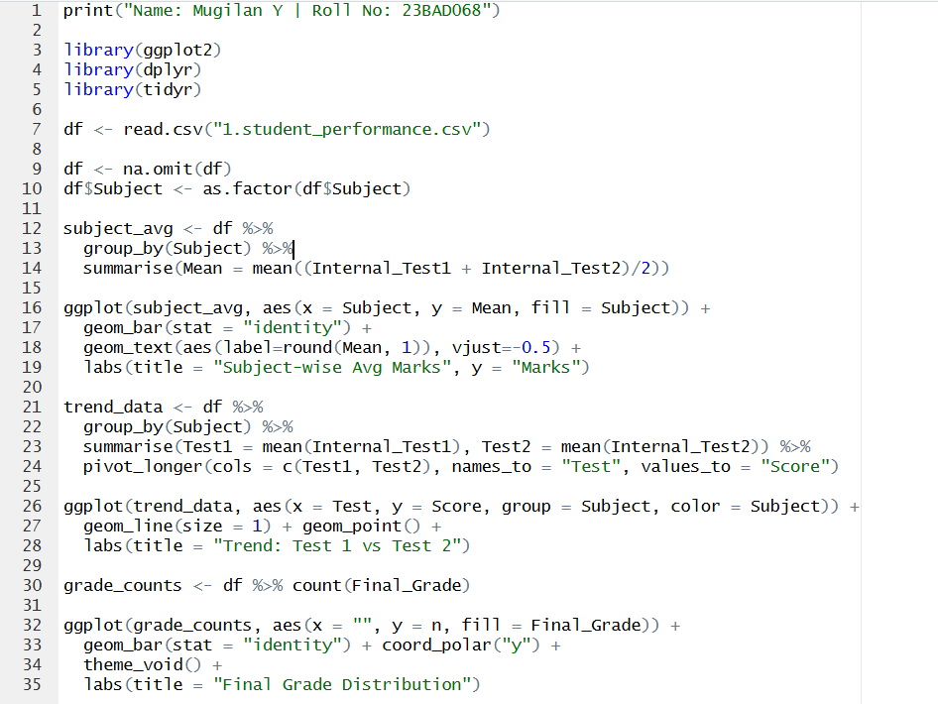

OUTPUT:
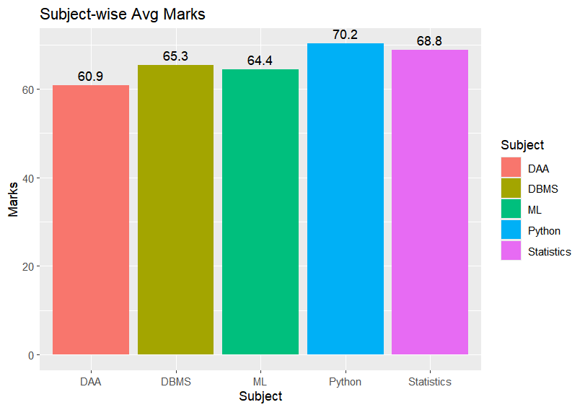
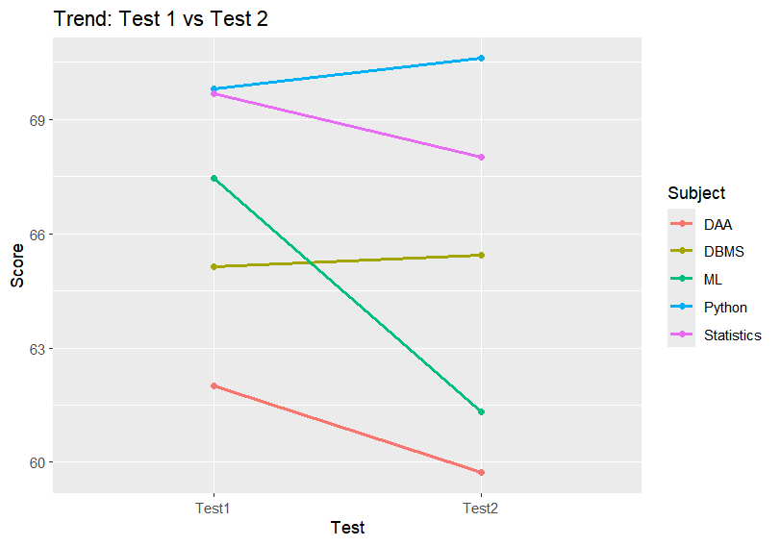
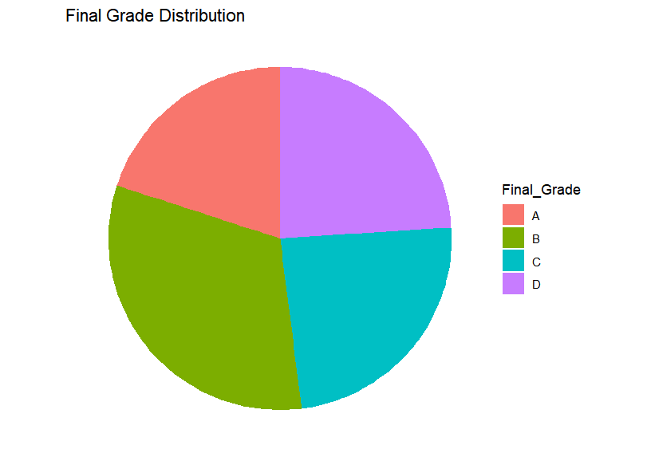

POST-LAB QUESTIONS (PROVIDE BRIEF ANSWERS TO THE FOLLOWING QUESTIONS)
- Which subject shows consistently low performance and why?
Answer: DAA (Design and Analysis of Algorithms) shows the lowest performance with an average of 60.9, as seen in the bar chart. This is likely due to the subject's abstract nature and heavy reliance on complex logic and mathematics compared to more practical subjects like Python (which had the highest average of 70.2).
- Why is a line chart suitable for trend analysis?
Answer: A line chart connects data points chronologically (from Test 1 to Test 2), effectively visualizing the direction (improvement vs. decline) and magnitude (steepness) of change. For example, the chart clearly shows a sharp decline in marks for ML and DAA, which would be harder to see in a table.
- What limitations does a pie chart have in analytics?
Answer: Pie charts lack a common axis, making it difficult to visually compare the precise size of similar slices (e.g., distinguishing between the quantity of 'A' grades vs 'B' grades). They also become cluttered and unreadable if the number of categories (slices) increases.
- How can this analysis help curriculum planning?
Answer: By identifying underperforming subjects like DAA, the department can make evidence-based decisions, such as allocating extra tutorial hours, revising the syllabus, or organizing remedial classes for specific topics before the final semester exams.
- How can such visualizations be integrated into AI-driven academic analytics
Answer: These visualizations can serve as the dashboard for an AI predictive model. While the AI analyzes historical patterns to predict future "at-risk" students, the visualizations provide the real-time interface for faculty to see these alerts and understand the underlying data trends immediately.

ASSESSMENT
Description | Max Marks | Marks Awarded
Pre Lab Exercise | 5
In Lab Exercise | 10
Post Lab Exercise | 5
Viva | 10
Total | 30
Faculty Signature

